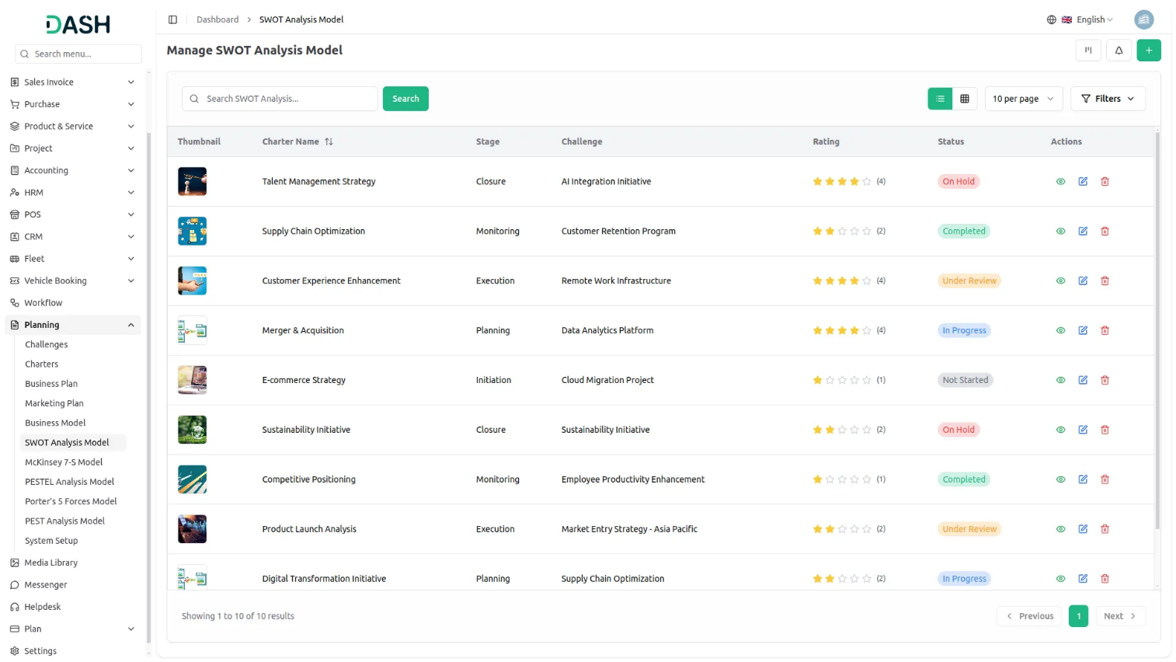

SWOT Analysis Add-On offers a dynamic way to assess your business environment by capturing Strengths, Weaknesses, Opportunities, and Threats in a structured format. Designed for flexibility, users can create detailed SWOT analyses with descriptions, attachments, notes, and stage assignments. Visualize your insights across grid, kanban, or tree views organized by challenges for deeper clarity. With built-in review and print functionality, This Add-On empowers smarter, more strategic decision-making.
Dependency Notice: This Add-On depends on the Planning Add-On, so you must purchase and activate it first to access the SWOT Analysis Model features.

Insight-Driven SWOT Explorer
Analyze every facet of your business with a powerful, all-in-one SWOT view. Capture key insights with fields for Strengths, Weaknesses, Opportunities, and Threats along with attachments, ratings, notes, and comments. Foster collaboration and informed decision-making by bringing your strategy into a centralized and interactive format.
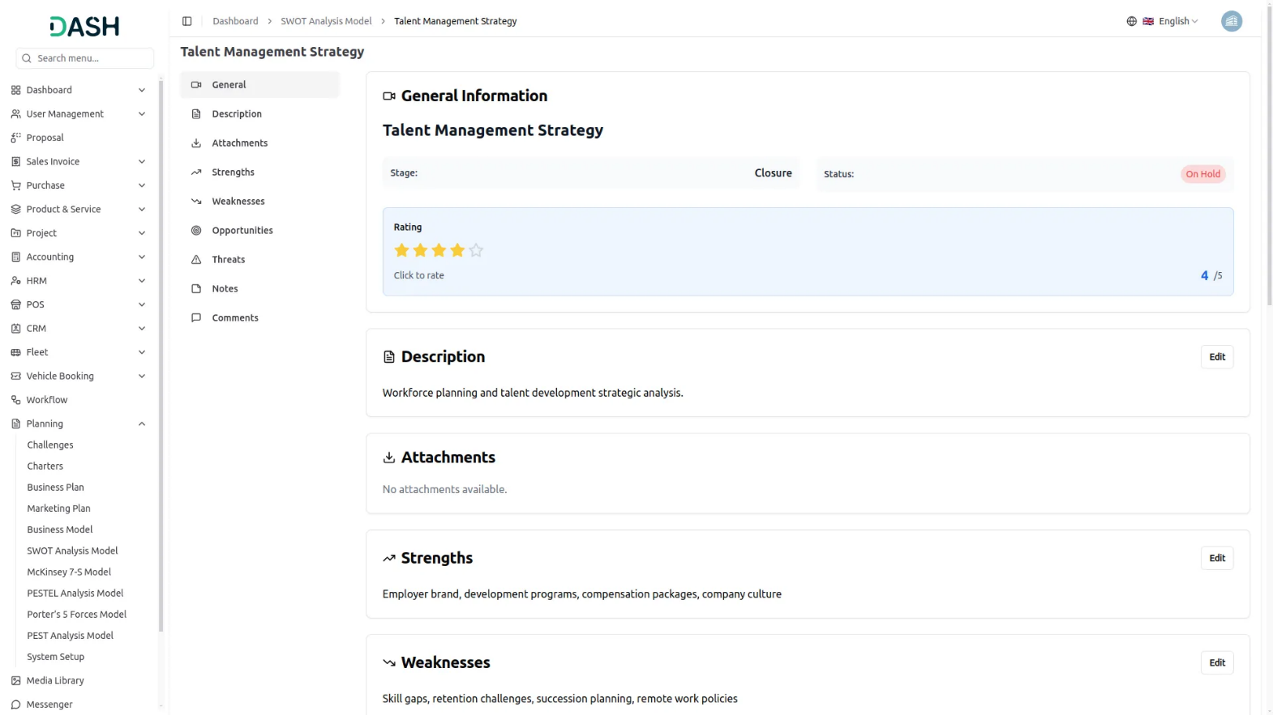

SWOT Analysis Overview Grid
Gain a comprehensive view of your SWOT Analysis Models in an intuitive grid format. This section displays key details like strengths, weaknesses, opportunities, and threats, along with essential data such as comments, attachments, challenge end time, and assigned users. With the ability to print, edit, or delete models, this feature allows you to efficiently manage and update your SWOT analysis for actionable insights.
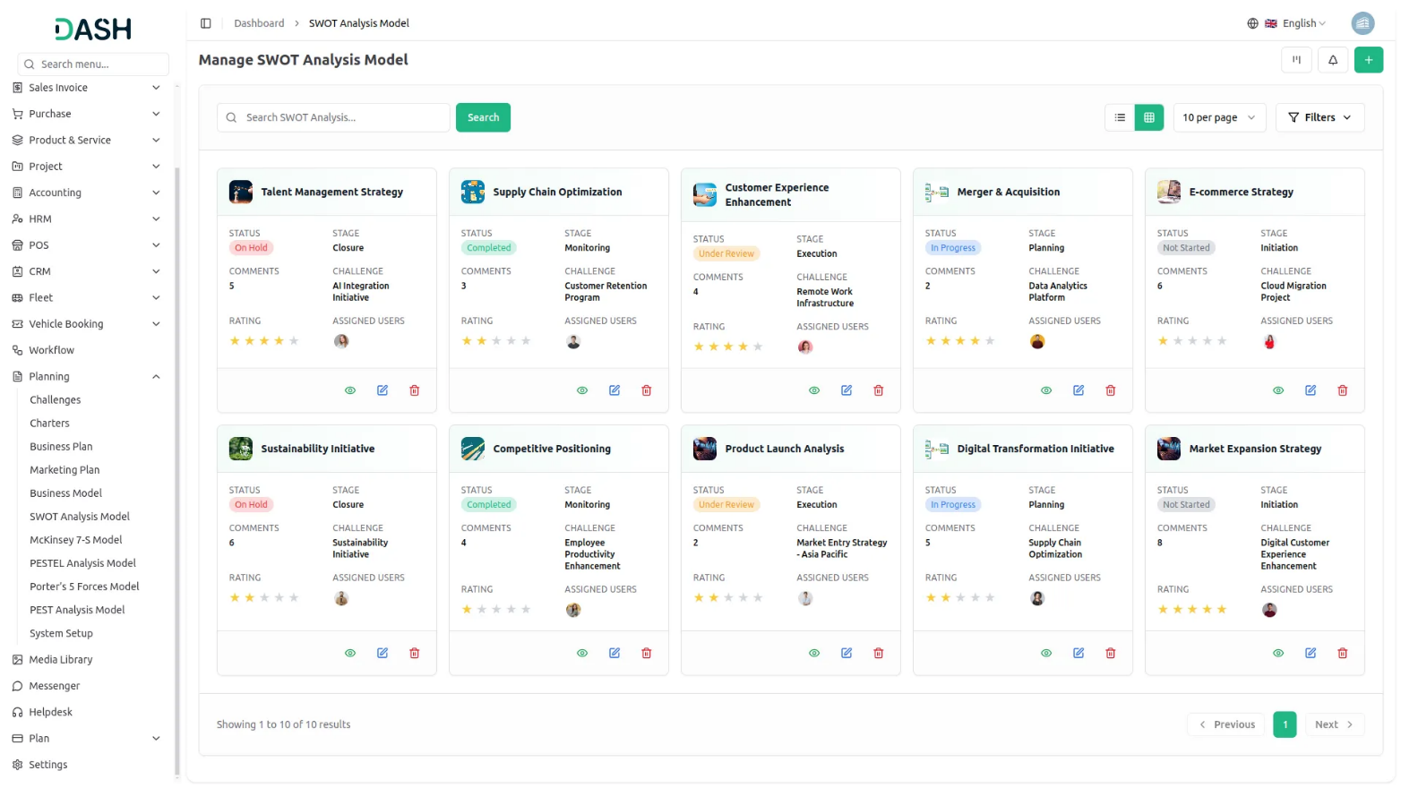
Track and Manage Weaknesses in Kanban
Efficiently track and assess weaknesses through the Kanban view of the SWOT Analysis Add-On. With the flexibility to organize SWOT models based on stages, you can easily see how weaknesses evolve over time. Each stage displays the total number of SWOT models, and with drag-and-drop functionality, you can seamlessly move them between stages. Additionally, you can print, edit, or update each model, ensuring continuous refinement of your strategies for improvement.

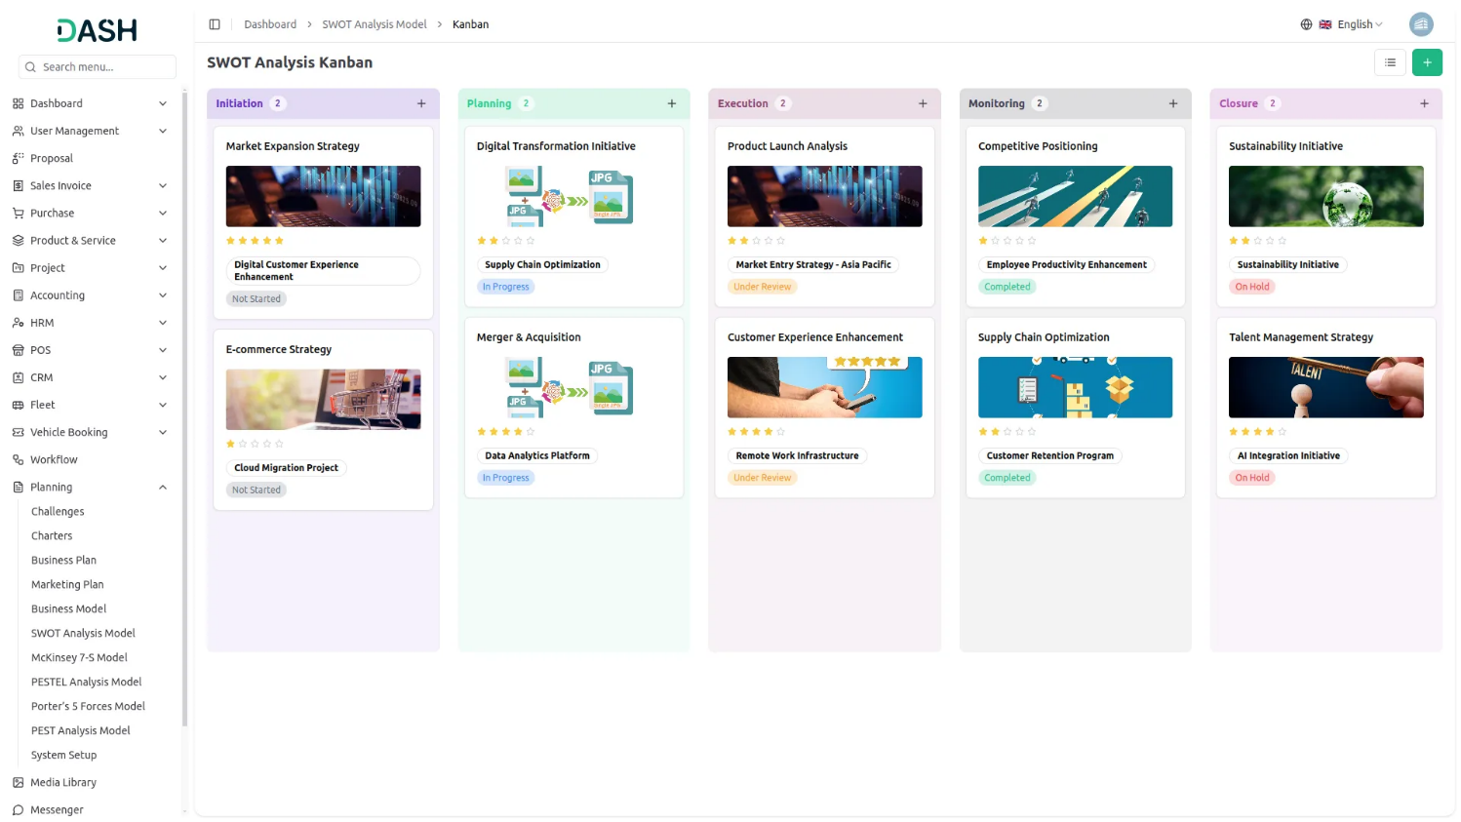

Opportunity Mapping with Tree View
Visualize and explore growth opportunities with clarity using the Tree View in the SWOT Analysis Add-On. Based on selected challenges, the structured tree format dynamically displays related SWOT models, helping you understand how opportunities align with specific business scenarios. This intuitive view enables smarter strategic planning and fosters a proactive approach to seizing potential.

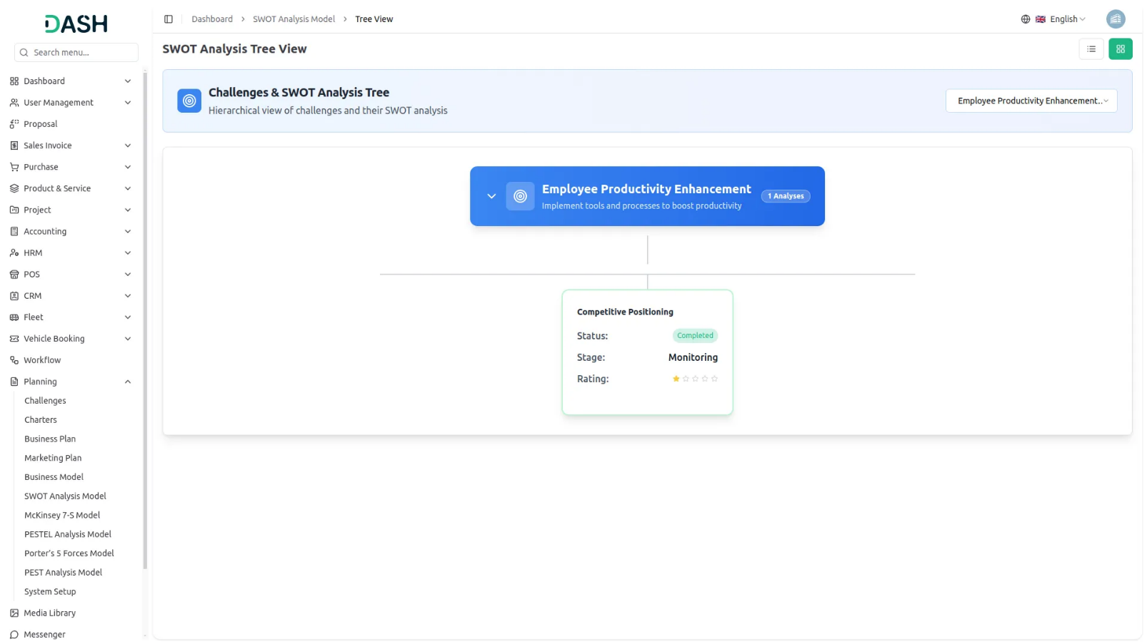

Introduction
The SWOT Analysis Model is a strategic planning software that helps organizations and teams evaluate their Strengths, Weaknesses, Opportunities, and Threats. This Add-On allows users to create comprehensive SWOT analyses linked to specific challenges, assign team members and roles, track progress through different stages, and manage multiple analyses through various viewing options including grid, kanban, and tree structure layouts.
Note: This Add-On is dependent on the Planning Add-On, so you need to purchase it first.
How to use the SWOT Analysis Model Add-On ?
Managing SWOT Analysis Model
- The default List View displays all SWOT Analysis Models in a comprehensive table format with multiple management options. At the top of the page, you’ll find buttons for Create SWOT Analysis Model to add new analyses, plus three alternative viewing options for different management preferences.
- The main table presents detailed information with columns for Thumbnail Image providing visual identification, Charter Name of the analysis model, Status fetched from System Setup showing current progress, Stage fetched from System Setup indicating analysis phase, Challenge fetched dynamically from Challenge Table showing associated business objectives, Rating for performance tracking, and Action column with management options.
- In the Action column, you have powerful options available: View to access complete analysis details and all strategic information, Edit to modify any aspect of the model including strategic assessments and team assignments, and Delete to remove analyses that are no longer relevant to your business strategy.

Creating SWOT Analysis Model
- To create a new SWOT Analysis Model, click the “Create” button at the top of the page. Start by entering the Name for your strategic analysis model, which should clearly identify the scope or focus of your competitive analysis.
- Select the Challenge from the dropdown menu, which fetches data from the Challenges. Important note: if the current date is greater than the Challenge End Date, you will not be able to create a SWOT Analysis Model, ensuring all analyses remain aligned with active or future business challenges.
- Upload a Thumbnail Image to provide visual identification for your analysis model, and Upload Video content if you have supporting presentations or explanatory materials. Choose the appropriate Status from the dropdown menu, which fetches options from System Setup, and select the relevant Stage also fetched from System Setup to indicate the current phase of your analysis.
- Assign the Users involved in this strategic analysis by selecting from the Users, and choose the appropriate Role from the Roles dropdown to define team member responsibilities. Add a comprehensive Description that outlines the purpose and scope of your strategic analysis.
- Continue with the strategic analysis components by entering detailed information for Strengths, explaining your organization’s internal positive attributes and competitive advantages. Document your Weaknesses by identifying internal areas that need improvement or pose challenges to your objectives.
- Add comprehensive details for Opportunities, outlining external factors that could benefit your organization or create growth potential. Complete the analysis by documenting threats, identifying external factors that could negatively impact your business or strategic objectives.
- Include relevant Notes for additional observations, methodology details, or strategic insights, and attach supporting files through the Attachments field for research data, market reports, or reference materials. Once all fields are completed, click “Create” to create your SWOT Analysis Model.

View SWOT Analysis Model
- To view a SWOT Analysis Model, click the “View” button in the Action column of any model in the list. This opens the SWOT Analysis Model Details page with a comprehensive view of all information organized in expandable sections for easy navigation.
- The view page is structured with multiple collapsible sections starting with the General section which is expanded by default. The General section displays the model name, associated challenge, thumbnail image, uploaded video, current status fetched from System Setup, stage information, assigned users from the Users, and their designated roles from the Roles.Additionally, users can add a rating from this view page, and the same rating is also displayed on the index page.
- Click on the Description section to expand and read the complete purpose and scope of the strategic analysis as entered during creation. This section provides detailed context about the analysis objectives and methodology. An “Edit” button is available below this section to add new description content.
- The Attachments section can be expanded to access all supporting files including research data, market reports, reference materials, or any other documents uploaded during the model creation process. You can download or view these attachments directly from this section. Use the “Edit” button below to upload additional attachments.
- Expand the Strengths section to review all internal positive attributes and competitive advantages documented for your organization. This section displays the complete list of strengths identified during the strategic analysis process. Click the “Edit” button below to include additional organizational strengths.
- The Weaknesses section shows all internal areas that need improvement or pose challenges to your objectives. Click to expand and review the comprehensive list of organizational weaknesses identified in the analysis. The “Edit” button allows you to document additional weaknesses as they are identified.
- Click on the Opportunities section to view external factors that could benefit your organization or create growth potential. This section outlines all the opportunities documented during the strategic planning process. Use the “Edit” button to include new opportunities as market conditions change.
- The Threats section displays external factors that could negatively impact your business or strategic objectives. Expand this section to review all identified threats and risk factors that may affect your organization. The “Edit” button enables you to document new threats as they emerge.
- The Notes section contains additional observations, methodology details, strategic insights, or any supplementary information added during the analysis creation. This section provides context and additional commentary on the SWOT analysis. Click the “Edit” button to include additional notes and observations.
- At last comes the comment section from where you can post comments easily. You can also attach files in the comments section if you want.

Kanban View
- The Kanban View organizes SWOT Analysis Models into columns based on their current stage, providing a workflow-based visualization with drag and drop functionality. You can easily move models between different stages by dragging cards from one column to another.
- Each Kanban card shows essential information including the total number of assigned users working on the analysis.
- The drag and drop functionality allows you to update the stage of any SWOT Analysis Model by simply moving it to the appropriate column. Action buttons on each card include View for detailed information, Edit for modifications, and Delete for removal. This view is ideal for tracking the progress of multiple analyses through different stages of completion.

Tree View
- To switch to Tree View, click the “Tree View” button at the top of the page. This view presents a hierarchical structure that displays challenges and their associated SWOT Analysis Model in an expandable tree format, showing the parent-child relationships clearly.
- The Tree View includes expand/collapse functionality, indicated by the arrow icon next to each challenge name. Clicking the arrow allows you to expand the challenge to reveal its associated models or collapse it to show only the challenge title, making navigation more organized and focused.
- In the Tree view, each challenge appears as a blue header bar with the number of plans indicated. When expanded, it displays the associated models beneath it in card format, showing key details including the model name, status, stage, and rating displayed as stars.

